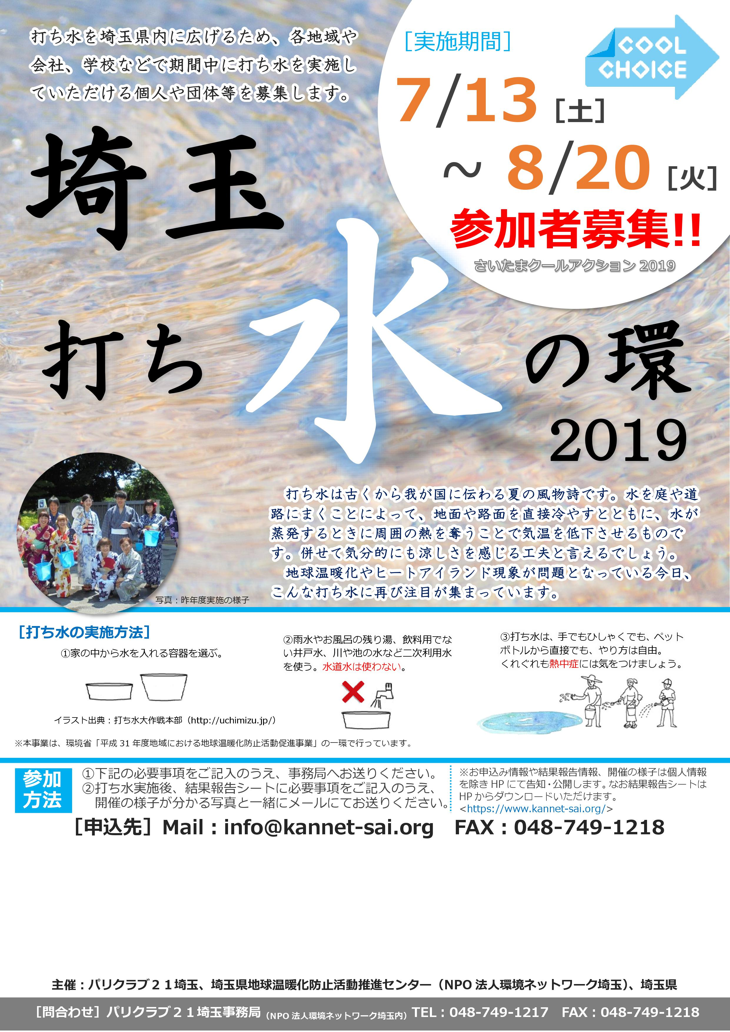

|  |  |  |  |  |  |  |
| --- | --- | --- | --- | --- | --- | --- |
| **実**  **施**  **者** | **団体名** |  | | | | |
| **住　所** |  | | | | |
| **お名前** |  | **電　話** |  | **メール** |  |
| **実施場所** | |  | | | | |
| **実施予定日** | |  | | | | |
| **参加** | **属性** |  | | | | |
| **規模** | **人程度** | | | | |